TEXAS HOLOCAUST AND GENOCIDE COMMISSION
2019 – 2020 Friends of the THGC Educator Grant
Application Form

Deadline for submission is Wednesday, October 16, 2019 at 5:00 p.m. C.S.T.

Before completing this application, please refer to the 2019 – 2020 Texas Holocaust and Genocide Commission (THGC) Educator Grant Criteria and Procedures document available at http://thgc.texas.gov/grants/educators-grant

All proposals must be typed. This application form is designed to be filled out electronically. As well, this application is meant to provide you with spaces to complete all necessary application requirements in one document so that multiple files are not submitted. Please contact Christian Acevedo at christian.acevedo@thgc.texas.gov or at 512.463.7998 if you require an alternate format.

PROPOSAL INFORMATION

Project Title: Grant Funds Requested (up to $1,000.00):

APPLICANT INFORMATION

Project Lead Name:

School/Institution Name (if applicable):

School District:

Principal/Superintendent: Principal/Superintendent Phone:

Principal/Superintendent E-mail:

District’s Chief Financial Officer: District’s Chief Financial Officer Phone:

District’s Chief Financial Officer E-mail:

School/Institution Type:

Public School Private School Homeschool

Charter School Private nonprofit School District

Other/name:

School/Institution’s Academic Calendar URL:

School/Institution’s Website URL:

PROJECT LEAD CONTACT INFORMATION

Project Lead Name:

Physical Address (where you work):

City: State: ZIP Code:

Mailing Address (if different):

City: State: ZIP Code:

Telephone (a number at which you can be directly contacted – a school’s front desk telephone will not suffice):

E-mail address (Please ensure that this e-mail account will be monitored and e-mails actually checked/read. The majority of communication will be through e-mail):

PROJECT NARRATIVE (Maximum two pages for the four elements of the narrative). Please respond to the four elements of the project narrative, described below, to the application. A template has been provided at the end of this form. The narrative can be no longer than two pages in length.

- Project Development
Describe the project goals and its activities. • How does your project encourage students’ learning about the Holocaust and/or genocides? • Does the project follow the Guidelines for Teaching about the Holocaust and/or Guidelines for Teaching about Genocide as set by the United States Holocaust Memorial Museum?

- Potential Impact and Feasibility
What audience will this project reach? • What are the goals and desired outcomes of the project? • How many individuals will this project reach? • What is the urgency and need for this project? • Will there be any pre-teaching involved before the actual project is implemented? If so, what? • Will this project reach Texas students in rural/smaller urban settings? • Will this project take place during class time, outside of class time, or be extracurricular?

- Project Participants
List yourself and any other adults who will help manage or direct the project. • What are your qualifications and those of any other individuals who will manage the project? • How many students do you anticipate being involved in the project? • What grade level(s) are the students who will be involved? • What, if any, sort of follow-up activities/assignments will students complete after the project is completed to ensure it was successful?

- Project Timeline
Create a timeline with specific calendar dates when project tasks will be accomplished. Projects must begin on or after Friday, November 1, 2019 and be completed prior to Friday, May 22nd, 2020, when a complete financial report of expenditures are due. Best practice is to complete the project and subsequent documentation to close the grant prior to the end of your academic school year. Please plan your activities with these dates in mind.

PROJECT BUDGET
Provide a detailed explanation of how all funds will be used to carry out the project. Break down your project costs based on which funds would come from the Friends of the THGC Educator Grant and which funds will come from cash and in-kind sources (from other donors, fundraising groups, your school district, the museum you are visiting, etc.) in order to meet the total of your projected project and its budget requirements. Any unused funds must be reimbursed to the Friends of the THGC and receipts MUST be turned in upon project completion. Please see the THGC 2019 – 2020 Educator Grant Criteria and Procedures document for a sample budget at: http://thgc.texas.gov/grants/educators-grant. You can also view a past budget example below.
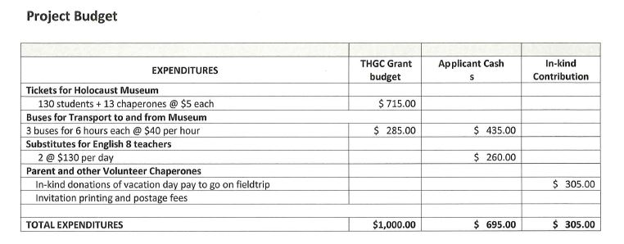

You can use this table to help create your budget.

EXPENDITURES | Friends of the THGC Grant | Applicant Cash | In-Kind Contributions
TOTAL EXPENDITURES | $ | $ | $

APPLICANT CERTIFICATION
I certify that all information contained herein is accurate or represents a reasonable estimate of future operations based on data available at the time of application and that there are no misstatements or misrepresentations in the information submitted herein or as a supplement:

Project Lead

Signature: _____________________________ Date: Click or tap to enter a date.

Name:

Title:

APPLICATION CHECKLIST AND DELIVERY
The following must be complete and received by the THGC by Wednesday, October 16, 2019 at 5:00 p.m. C.S.T. All materials must be included via attachments (PDF preferred) in an e-mail.

A complete ELECTRONIC application package will contain:
a signed, original application form
a project narrative
a project budget

You may submit your application electronically to:

christian.acevedo@thgc.texas.gov
Subject: Educator Grant Program

If circumstances require that you physically mail the application, please contact Christian Acevedo at christian.acevedo@thgc.texas.gov

The Friends of the Texas Holocaust and Genocide Commission generously funds this Educator Grant annually; however, it is Texas Holocaust and Genocide Commission staff who administratively oversee all grant processes. The Texas Holocaust and Genocide Commission’s staff is available to help you with this application. For assistance, please contact Christian Acevedo at christian.acevedo@thgc.texas.gov or 512.463.7998.

Please respond to the four elements of the project narrative, described below, to the application. You do not need to answer each question individually, especially if some are irrelevant to your project or if you can answer them in one sentence. The narrative can be no longer than two pages in length. Please feel free to delete the instructions/questions but keep the bold headings (1-4).

- Project Development
Describe the project goals and its activities. • How does your project encourage students’ learning about the Holocaust and/or genocides? • Does the project follow the Guidelines for Teaching about the Holocaust and/or Guidelines for Teaching about Genocide as set by the United States Holocaust Memorial Museum?

- Potential Impact and Feasibility
What audience will this project reach? • What are the goals and desired outcomes of the project? • How many individuals will this project reach? • What is the urgency and need for this project? • Is the size and scope of the proposal appropriate for this project? • Will this project reach Texas students in rural/smaller urban settings? • Will this project take place during class time, outside of class time, or be extracurricular?

- Project Participants
List yourself and any other adults who will help manage or direct the project. • What are your qualifications and those of any other individuals who will manage the project? • How many students do you anticipate being involved in the project? • What grade level are the students who will be involved? • What, if any, sort of follow-up activities/assignments will students complete after the project is completed to ensure it was successful?

- Project Timeline
Create a timeline with specific calendar dates when project tasks will be accomplished. Projects must begin on or after Friday, November 1, 2019 and be completed prior to Friday, May 22nd, 2020, when a complete financial report of expenditures are due. Best practice is to complete the project and subsequent documentation to close the grant prior to the end of your academic school year. Please plan your activities with these dates in mind.

